MetaSource Word Document
A formatting guide

Table of Contents
Basics 1
Spacing 1
Alignment 1
Lists 1
Charts 2
Logo 2
Images 3
Footer 3

Basics
Paragraph text looks like this. Paragraph text paragraph text paragraph text paragraph text paragraph text paragraph text paragraph text paragraph text paragraph text paragraph text paragraph text paragraph text paragraph text paragraph text paragraph text paragraph text paragraph text paragraph text paragraph text paragraph text paragraph text paragraph text paragraph text paragraph text paragraph text paragraph text paragraph text paragraph text paragraph text paragraph text paragraph text paragraph text paragraph text paragraph text paragraph text paragraph text paragraph text.

Spacing
To start a new section, press the enter key twice. This prevents sections from running into each other. Under the “Layout” tab, “Spacing” for the entire document should be set to the following:
Before: 0pt
After: 6pt

Alignment
Headers and paragraph text should be left-aligned.

Lists
- Level 1 bullets are filled circles in MetaSource dark teal (#287278). Their bullets have no indent from the previous paragraph, and their text is indented to 0.25.
  - Level 2 bullets are open circles in MetaSource dark teal (#287278). Their bullets are indented 0.25 from the previous paragraph, and their text is indented to 0.5.
- Numbered lists are bolded and MetaSource dark teal (#287278). The numbers are not indented from the previous paragraph, and their text is indented to 0.25.
  - Subcategories of numbered lists use letters. The letter is indented 0.25 from the previous paragraph, and the text is indented to 0.5.

Charts
Chart Header | Chart Header
Table shading in alternating rows improves legibility. | Table shading light teal.
Alternate table rows between white and light teal. | Table shading white.
Chart content | Chart content
Chart content | Chart content

Logo
MetaSource documents should always include a MetaSource logo, either the Main logo or the Mortgage logo. Depending on the type of document, the relevant logo will either be placed at the top of the document, or in the footer.

 | 
Main logo | Mortgage logo

Images
Images and screenshots included in documents should have a MetaSource green (#799900) border with 1 ½ weight, like the example below.

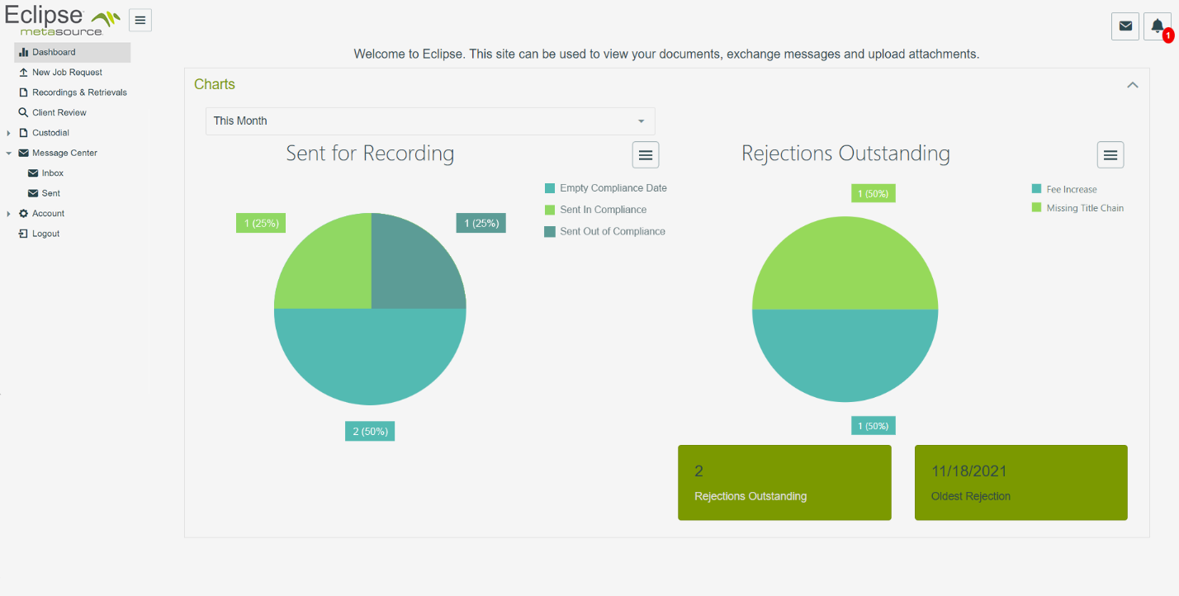

Footer
Footer layout depends on the type of document. Page numbers are always formatted to include the total length of the document. So, in this 3-page document, each page number is followed by “of 3”.

